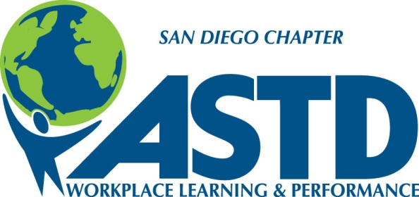
The San Diego Chapter
of the
American Society for Training & Development
announces our Ninth Annual Your Turn to Learn Conference
on Tuesday September 24th, 2013
and invites participation from
vendors and sponsors interested in reaching this Training & Development community
We are a professional organization of over 300 Training & Development professionals. We’re one of the twelve largest ASTD chapters in the country. Approximately half our members are mid- to senior-level employees in San Diego’s business community; others are service providers and vendors in the Training & Development field. A thriving segment of our membership is students (undergraduate and graduate) and career-changers with significant corporate experience who are breaking into this growing, vital field of Training & Development. In addition to our Chapter members, our database includes over 3,000 non-members who make use of our relevant, useful resources.
Between 125 and 175 people attend our annual conference each year.

Conference Sponsorships include:
- Your quarter-page advertisement in our printed Conference Program
- Your flyer, brochure, and/or giveaway item (ex.: a pen or other branded item) included in each attendee’s registration packet.
- Your logo, with a link to your website, on our Sponsors’ Page on our website for one year.
- Your logo in our Sponsors’ banner on every page of our website for one year.
- Printed adhesive mailing labels with members’ addresses (approximately 350 – 400 labels).
- Your logo and company name on our Sponsors’ Thank-You sign in the main ballroom at the conference.
- One conference pass, plus the opportunity to purchase additional passes at the members’ price.
Sponsorships are $1,000.

Sponsor a “Branded Area” promoting your company (in addition to your basic sponsorship)
Opportunities include:
- Conference Tote Bag – provide 150 tote bags with your logo OR we will purchase the tote bags with your provided logo graphic for $500
- PEAK Award Program – the annual PEAK (Performance Excellence and Applied Knowledge) awards will be part of our closing ceremonies, and include a separate printed program. Your logo, company name, and 40-word description included in the program for $300.
- Your Turn to Learn Conference program – sponsor the printing of our Conference program for $500, and your logo, company name, and 40-word description appears on the back cover.
- Lunch – for $500, one single Lunch sponsor will have their logo, company name, and tagline displayed on a sign in the dining space.
- Breakfast – for $500, one single Breakfast sponsor will have their logo, company name, and tagline displayed on a sign in the breakfast buffet area.
- Post-Conference Happy Hour – for $500, one single Happy Hour/Networking sponsor will have their logo, company name, and tagline displayed on a sign in the Happy Hour area.

Conference Vendor Space
The Conference includes a vendor area for companies who would like to present their services to our attendees. We will be conducting several activities specifically designed to encourage attendee interaction with every vendor, and ample time is allocated on the schedule for visiting the vendor area.
Sole Proprietors: We have a special rate for our self-employed / independent practitioner Chapter members: just $200 for your vendor space and one pass to the conference.
Companies and Non-Members: Tables for companies with employees and non-member sole practitioners are $400, which includes two passes to the conference.
Additional passes may be purchased at our members’ price.

To sponsor our Your Turn to Learn Conference and/or attend as a vendor, please fill out the form on the following page.
Questions? Contact the Conference Chairs (Jane Gredvig and Teresa Hanley) at 2013yttl@gmail.com
We look forward to seeing you on September 24th!

To sponsor and/or attend our event as a vendor, please complete the form below.
Name:
Title:
Company:
Address:

Phone:
Email:
- We wish to sponsor the event for $1,000.
- We wish to purchase an additional Branded Area sponsorship for (enter name of Branded Area):

at an additional price of (enter price specific to the area): $
- I am a San Diego ASTD Chapter member and an independent, sole proprietor, and I wish to attend the conference as a vendor for $200.
- We are a company and/or not a Chapter member, and we wish to attend the conference as a vendor for $400.
- We would like to purchase conference tickets at the members’ rate.
# of tickets * $145.00 (through September 10) or $175 (after September 10th) = total for tickets.
$ TOTAL DUE
Payment may be made in check (payable to ASTD San Diego) or by credit card.
Mail this form with your check to:
ASTD San Diego
5694 Mission Center Road
#218
San Diego CA 92108
OR complete this form and email it to office@astdsandeigo.org. Our office manager, Shannon Hoolihan, will be in touch to take your credit card number on the phone.
Once your payment has been confirmed, a Conference Committee member will be in touch with you to finalize arrangements, including graphics files of your logo and Conference Program advertisement.

